大数据与机器学习国际研讨会
主讲人简介

1. 香港中文大学 工程学院 Irwin King教授、博导
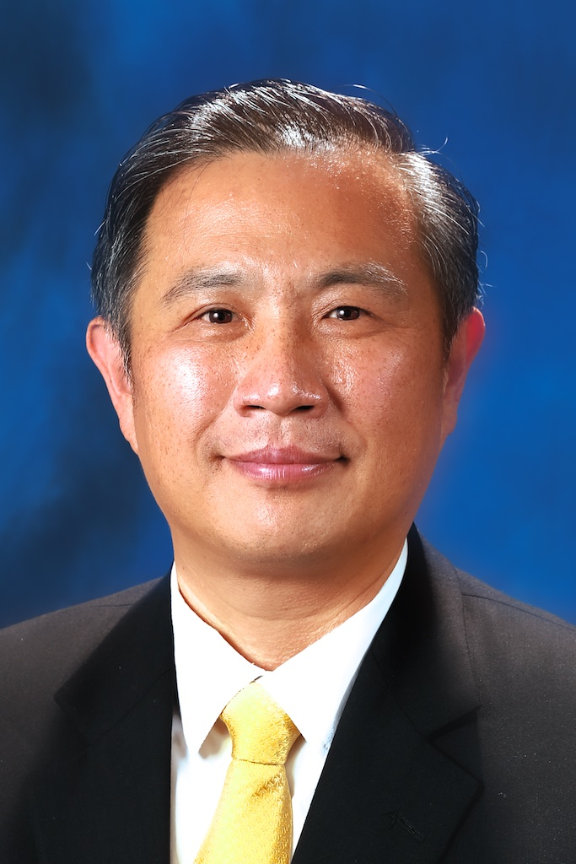 Irwin King's research interests include machine learning, social computing, web intelligence, data mining, and multimedia information processing for Big Data. In these research areas, he has over 225 technical publications in journals and conferences. In addition, he has contributed over 30 book chapters and edited volumes. Prof. King is Associate Dean (Education), Faculty of Engineering and Professor at the Department of Computer Science and Engineering, The Chinese University of Hong Kong. He is also Director of the Shenzhen Key Laboratory of Rich Media and Big Data. Recently, Prof. King has been an evangelist in the use of education technologies in eLearning for the betterment of teaching and learning.

2. 美国康奈尔大学 王飞副教授、博导
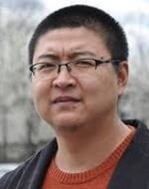2008年清华大学自动化专业博士毕业，2009年-2010年在康奈尔大学统计系做博士后，2010年在IBM沃森研究中心当研究员，2015年又任职于康涅狄格大学计算机系副教授。在Google Scholar上获得3000多次引用，H指数为31。迄今为止，在国际期刊和国际会议上已经发表了近135篇高水平论文，其中国际期刊论文39篇，国际会议论文96篇（CCF A 类42篇）；在相关方向的顶级国际会议和杂志上(如ICML, KDD, SIGIR, AAAI, IJCAI, CVPR, TPAMI)发表了超过100篇学术论文，并在KDD，ICDM，SDM, CIKM以及PAKDD等许多顶级国际学术会议上做过8次专题报告(Tutorial)，组织超过10次研讨会(Workshop)。论文累计引用数3585，H-index 31；2014年获得美国医学信息学学会转化生物信息学峰会最佳论文提名；2011年获得国际应用数学学会数据挖掘年会最佳论文候选；2011年全国优秀博士论文（百篇）获得者；2010年获得国际电子电器工程师协会数据挖掘年会最佳论文提名；共计10次在国际会议上做专题报告（均为3-4小时）；主持研发的基于病人相似性的决策支持系统促成了IBM有史以来第一个医疗相关的软件产品IBM Patient Care and Insights；申请美国及国际专利30项，目前已有3项获批；在IBM两次获杰出贡献奖，七次获发明成就奖；2013年青年千人计划入选者。

3. 西交利物浦大学 电气电子工程系 黄开竹副教授、博导
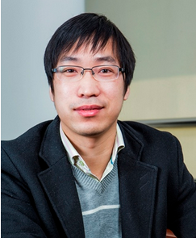西交利物浦大学电气电子工程系的副教授、博导，是电子科技大学计算机科学与工程学院协议教授。迄今为止，他在Springer出版了6本英文学术书籍，在国际期刊和国际会议上已经发表了200多篇高水平论文，Google引用次数超过1500次。此外还拥有6项国家专利。2010年以来作为项目负责人已获得经费逾400万。2007年至今，担任亚太神经网络协会Secretariat。国际杂志Cognitive Computation担任Editorial Board Member。在国际Springer Book Series Bio-Neuroinformatic 担任Advisory Board Member。中国计算机学会模式识别与人工智能专委会委员，中国人工智能学会模式识别专委会委员。在多个国际著名会议上担任组织工作，比如ICONIP2014程序主席、2012-2014年中德双边青年科学家前沿研讨会（SINOGFOS）的组织委员会成员、2012-2014年国际数据挖掘与安全研讨会（DMC）组织主席、ACML 2015 Publication Chair、ACPR2011 Publicity Chair、ICDAR 2011 Publication Chair等。

4. Texas A&M University, Department of Computer Science and Engineering, Xia "Ben'' Hu
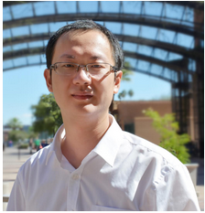Dr. Xia "Ben'' Hu is currently a tenure-track Assistant Professor at Texas A&M University in the Department of Computer Science and Engineering. He received his Ph.D. in Computer Science and Engineering from Arizona State University, and M.S. and B.S. in Computer Science from Beihang University, China. At Texas A&M, Dr. Hu directs the Data Analytics at Texas A&M (DATA) Lab and is also affiliated with the Center for the Study of Digital Libraries and the Center for Remote Health Technologies and Systems. The DATA Lab currently consists of five Ph.D. students, four M.S. students and two undergraduate students. Research focus of the DATA Lab is to develop data mining and machine learning algorithms with understanding of theoretical properties to better discover actionable patterns from large-scale, networked, dynamic and sparse data. Existing research projects are directly motivated by, and contributes to, applications in social informatics, health informatics and information security. As a result, Dr. Hu has published nearly 60 papers in several major academic venues, including WWW, SIGIR, KDD, ICDM, SDM, WSDM, IJCAI, AAAI, CIKM, ICWSM, etc. One of his papers was selected in the Best Paper Shortlist in WSDM'13. He is the recipient of the 2014 ASU President Award for Innovation, and Faculty Emeriti Fellowship. His work has been featured in the several news media, including ACM TechNews, New Scientist, Defense One, and others. Updated information can be found at http://faculty.cs.tamu.edu/xiahu/.

5. 浙江大学 计算机科学与技术学院 朱建科副教授、博导
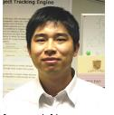Jianke Zhu is an Associate Professor in College of Computer Science at Zhejiang University. He received his Ph.D degree in Computer Science and Engineering from The Chinese University of Hong Kong. He was a postdoc in BIWI Computer Vision Lab at ETH Zurich. Dr. Zhu's research interests include computer vision and multimedia information retrieval. He is a member of the IEEE.

6. Carnegie Mellon University (CMU), philosophy department, Kun Zhang
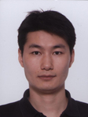

Kun Zhang is an assistant professor in the philosophy department at Carnegie Mellon University (CMU) and a senior research scientist at Max-Planck Institute (MPI) for Intelligent Systems, Germany. His main research interests include causal discovery, machine learning, neuroscience, and large-scale data analysis. He has made a series of contributions in solving some long-standing problems in causality, such as how to distinguish cause from effect and how to make nonparametric conditional independence test reliable. He has served as a senior program committee member or area chair for a number of conferences in machine learning or artificial intelligence, and organized various academic activities to foster interdisciplinary research in causality.

